# **Project portfolio**

# **Global Country Information Dataset 2023**

# **Introduction:**

This extensive dataset contains a wealth of information about all countries worldwide. It covers a wide range of indicators and attributes, including demographic statistics, economic indicators, environmental factors, healthcare metrics, education statistics, and much more. With every country represented, this dataset provides a comprehensive global perspective on various aspects of nations, allowing for in-depth analyses and cross-country comparisons.

The following data base are main sources of finding Health care, economic indicators, environmental factors and Education sector.

# Sources:

This dataset was collected from the Kaggle website

# SQL:

The data is imported into MySQL Workbench for further analysis to identify and address business problems by running specific queries.

## Data Cleaning:

In order to conduct our analysis, first start by extracting the data into Excel and then proceed to clean the data by removing duplicates, standardizing it, and verifying its accuracy. Once the data is ready, then will import it into MYSQL Workbench and Power Bi. It thoroughly explains the issues using queries from MYSQL Workbench, accompanied by compelling visuals from the Power Bi dashboard.

# SQL Business Problems Queries:

**Question 1**: How do CO2 emissions, urban population and gasoline prices in different countries correlate? Is there any impact of lower or higher gasoline prices on CO2 emissions?

**Trend**: countries with more urban population and gasoline prices less than $1 are at the top of CO2 emission.

**Question 2**: How do CO2 emissions and Forested area in different countries correlate?

**Trend**: countries with less forested area and more urban population are at the top of CO2 emission.

**Question 3**: What is the relationship between infant mortality and life expectancy of world countries?

**Trend**: High infant mortality and decreases life expectancy thus necessitates more health facilities.

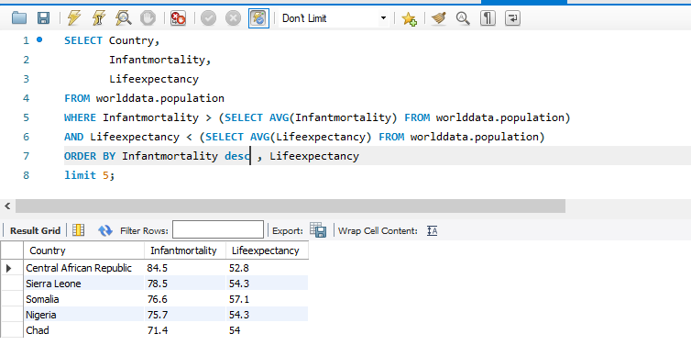

**Question 4:** Relationship between the size of a country, birthrate and population?

**Trend**: countries with large land areas and high birth rates have large populations.

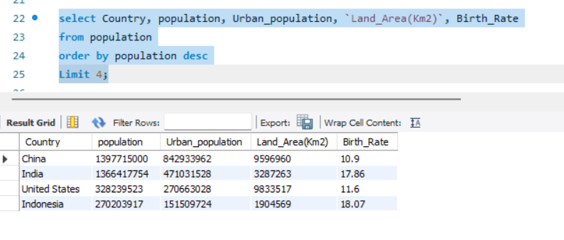

**Question 5:** Relationship between the urban population and its overall population?

**Trend**: countries with high urban populations have overall large populations.

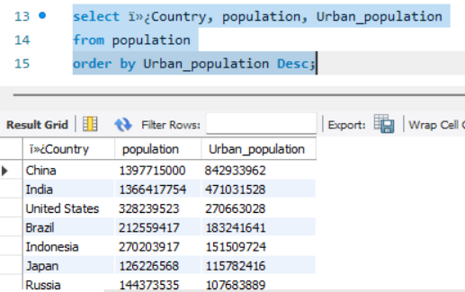

**Question 6:** Relationship between the population labor force participation % and the unemployment rate of a country?

**Trend**: countries with high unemployment rates have less population labor force participation %.

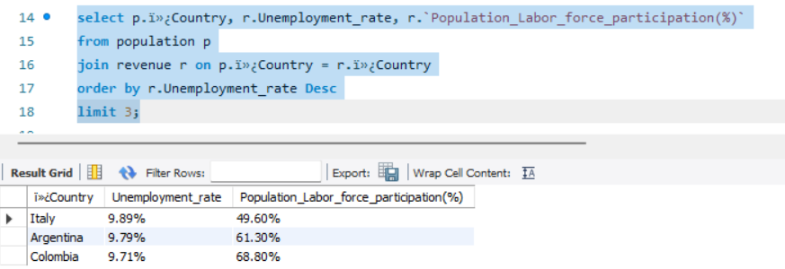

**Question 7:** Relationship between the gross primary and secondary education enrollment of countries and the unemployment rate?

**Trend**: countries with high unemployment rates have high gross primary and secondary education enrollment.

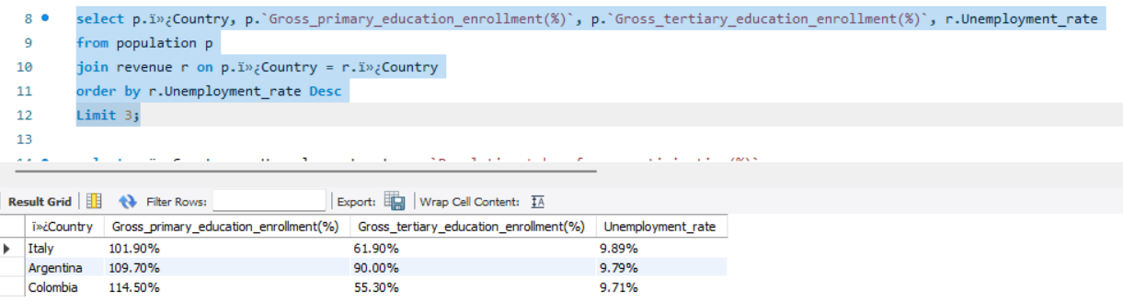

**Question 8:** Relationship between the population labor force participation % of countries and minimum wages?

**Trend**: countries with high population labor force participation % have low minimum wages so are more suitable for industrial setups.

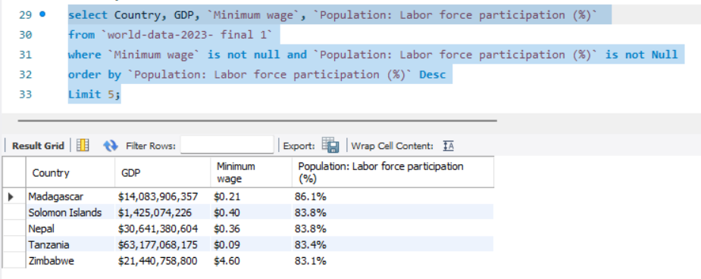

**Question 9:** Relationship between urban population, GDP and total tax rate of countries?

**Trend**: countries with high urban populations have high total tax rates and GDP.

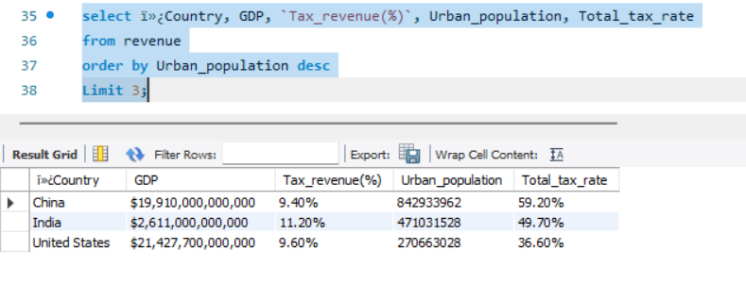

# **Data dictionary**

|  |  |  |  |  |
| --- | --- | --- | --- | --- |
| Field Name | Data Type | Field Size | Description | Example |
| Country | Varchar | 15 | Name of Country | Pakistan |
| Density | Integer | 14 | Density of each country | 1345823 |
| Agricultural Land( %) | var char | 12 | Total agriculture Land | 59% |
| Land Area(Km2) | float | 15 | Total Land area of each country | 230079 |
| Armed Forces size | Integer | 12 | Total Army country have | 6500000 |
| Birth Rate | float | 10 | Total birth Rate of each country | 65.8 |
| Capital/Major City | Text | 8 | capital/major city of country | New York |
| Co2-Emissions | var char | 4 | each country produced CO2 | 43% |
| CPI | float | 15 | CPI of every country | 29.20% |
| CPI Change (%) | var char | 3 | CPI change percentage | 23% |
| Fertility Rate | float | 13 | Rate of fertility of each country | 34% |
| Forested Area (%) | var char | 15 | total percent to forest area | 22% |
| Gasoline Price | float | 5 | Gasoline price of country | 372.68 |
| GDP | integer | 9 | GDP of each country | 5500000 |
| Gross primary education enrollment (%) | var char | 2 | total primary education percentage | 27% |
| Gross tertiary education enrollment (%) | var char | 2 | Total education for country | 78% |
| Infant mortality | float | 9 | total infant mortality in each country | 800 |
| Life expectancy | float | 3 | expectancy of life in each country | 86.5 |
| Maternal mortality ratio | float | 2 | ratio of maternity in each country | 1:03 |
| Minimum wage | integer | 11 | Minimum wage each country have | 4560000 |
| Out of pocket health expenditure | integer | 11 | Total expenses covered by people own pocket | 60% |
| Population | integer | 10 | Total population | 8406478 |
| Population: Labor force participation (%) | var char | 2 | Total lavour forced to work in each country | 30% |
| Tax revenue (%) | var char | 2 | Revenue of each country got | 34% |
| Total tax rate | integer | 2 | Tax Rate of each country | 22% |
| Unemployment rate | float | 2 | Total Unemployed people's | 45% |
| Urban population | integer | 10 | Urban Popular of country | 6755000 |

# Entity Relationship Diagram:

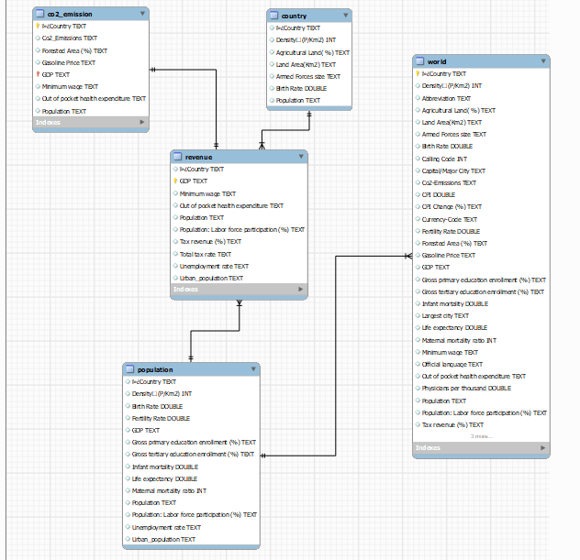

# Recommendation

The efficient CO2 reduction strategy for countries with high urbanization levels and low gasoline should therefore focus on funding renewable energy as well as improving on public transport. Countries which have undergone the process of urbanization and have relatively scarce natural resources, should compensate their deficit by planting green areas in cities as well as launching programs of afforestation. It thus suggests that the construction of better health care facilities and provision of enhanced services are indispensable since the infant mortality rate as well as the life expectancy is low. Much attention should be paid to the population and its reasonable number in countries with a large territory and high birth rate. The given inference points at the fact that large populations could always be attributed to growth in the urban populations hence the significance of urban planning. Countries experiencing high unemployment rates and low labor force participation should consider implementing policies to encourage employment and stimulate economic activity. Similarly, nations with high rates of enrollment in education programs should ensure that the skills and knowledge gained translate into meaningful job opportunities. In countries where labor force participation is high but minimum wages are low, it may be necessary to enact policies that safeguard workers' rights, especially if these countries are looking to attract industrial investments. Furthermore, the correlation between high urban populations and high GDP/tax rates underscores the significance of strategic economic planning to leverage urban economic potential while promoting equitable growth.

* The industrial setups in countries with high population labor force participation % and low minimum wages will benefit both the industrialists and the countries
* Enhanced gross primary and secondary education enrolment will reduce unemployment by creating more opportunities apart from labor work
* Education to enhance skilled labor in countries with less population labor force participation will reduce unemployment
* Forestation is the key to overcome CO2 emission problem